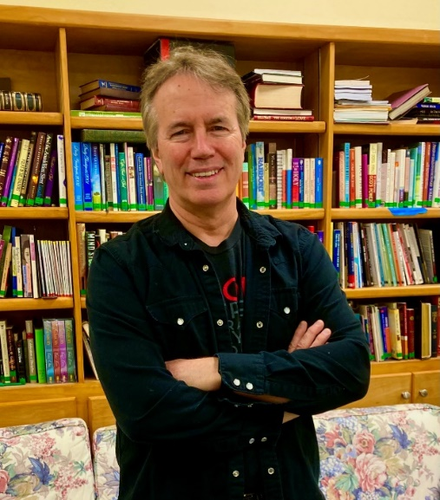
NEW DOVER UMC
CHURCH CONFERENCE, 2022
SENIOR PASTOR’S REPORT
“A YEAR OF TRANSITION!”

District Superintendent Sang-Won Doh,
Attenders of the Church Conference,

Grace to you and peace!
Last conference I reported that New Dover had a remarkable year in terms of participation in, and overall effectiveness of our ministry, achieving goals that a couple of years ago would have been thought unreachable. This year has been one of exciting transition as we have (sort of!) emerged from the throes of the Covid pandemic, and steadily returned to live worship and ministry. We have built upon our past successes such as Bread Breakers, the Dominican Republic mission at Los Cocos, Sunday School, YAYA, and Vacation Bible School. We have started up new projects such as Stars for Charity. And we have revisited successful missions of the past like Christian Outreach Project.
What follows is my summary of how we of NDUMC, in the year since last Conference, have responded to God’s call upon our lives of discipleship and fellowship.

OUTREACH

New Dover’s outreach ministry, chaired by the incomparable Paulette Harland, continued to grow both in terms of volunteer hours and neighbors served, locally and globally.

DOMINICAN REPUBLIC MISSION

Paulette made two trips to Los Cosos, one in the fall, and another in the spring when she was accompanied by Naomi Hunt. Together they helped build another house and, despite postal delays, distributed of over 30 donated boxes of clothing, food, and supplies. After each excursion, the mission was celebrated with pictures, videos, and testimony during Sunday worship.

MISSION CENTRAL

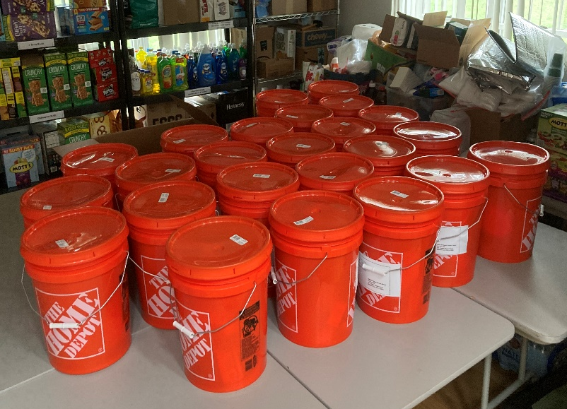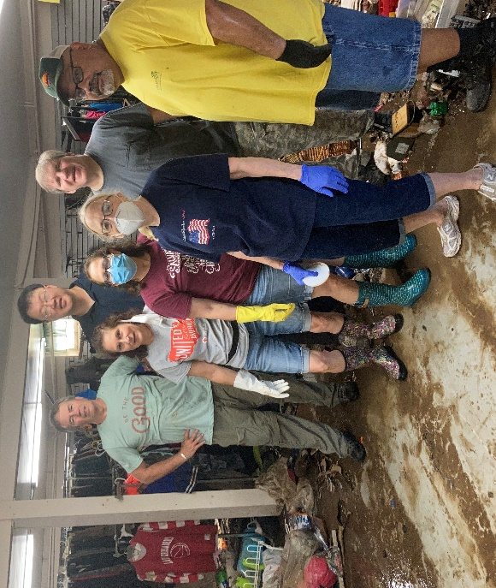

As the Central New Jersey hub of Mission Central we continued to collect and distribute flood relief buckets, health kits, and educational supplies donated by our congregation and other churches in our region. In the meantime we continue to develop plans on expanding our facilities, utilizing the donation from the estate of Evelyn Millard. Our plan is to break ground on this expansion no later than the spring of 2023.

LOCAL FOOD DISTRIBUTION

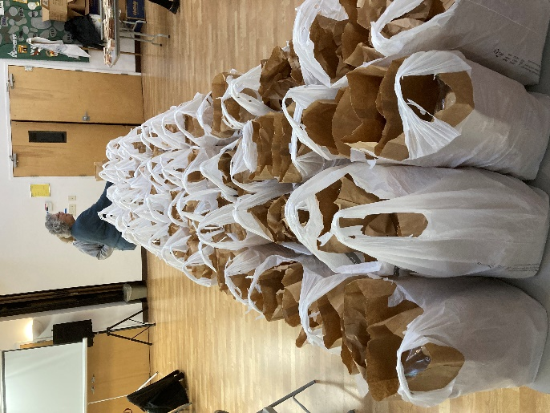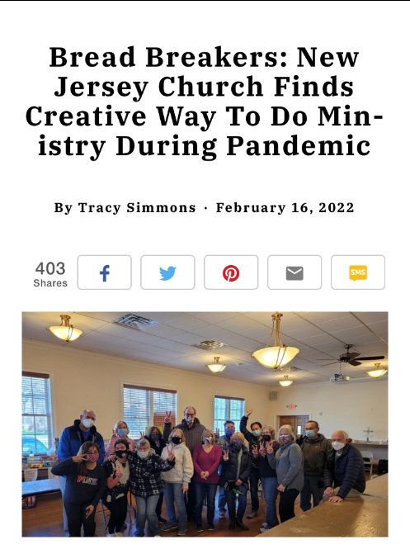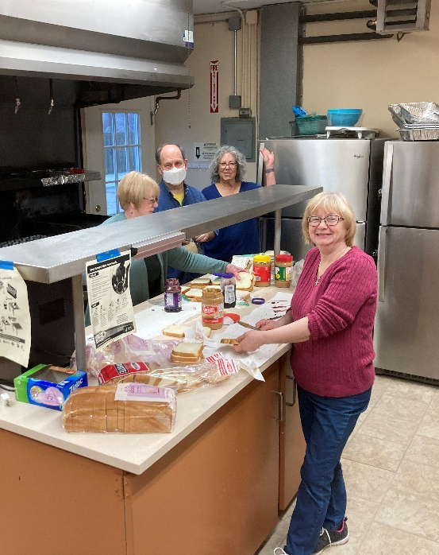

We continue to partner in our world-renown Bread Breakers food mission with Wesley UMC in South Plainfield, and Centenary UMC in Metuchen. Every Friday around a dozen volunteers gather at 8:00 AM to assemble bags containing sandwiches and other food items for distribution to our food-insecure neighbors via St. Joseph’s Social Center, Bianca Flowers, Food for Friends, and Hands of Hope. Once again, we have expanded the number of partnerships with local Wawa convenience stores increasing the number of days we pick up and deliver frozen food items from four to five. From September 1st, 2021 to August 31st 2022 we distributed 30,324 sandwiches and 15,152 complete meals, as well as thousands of Wawa items. This was an increase of 6,229 sandwiches and 3,107 meals over last year’s total! Altogether we were able to feed over 60,000 of our neighbors over the course of the year!

For his work in planning and inspiring our food ministry, Brian Richards and Bread Breakers received the Laity Recognition Award from the Conference, which was presented to Brian by our District Superintendent Sang Won Doh during worship on July 10! In his acceptance speech, Brian made sure the whole congregation knew he was accepting on behalf of the entire church, because Bread Breakers is a total team effort. With Brian moving out of state, we were blessed to have Tami Pino and others stepping into his sizable shoes and so far the ministry hasn’t skipped a beat!
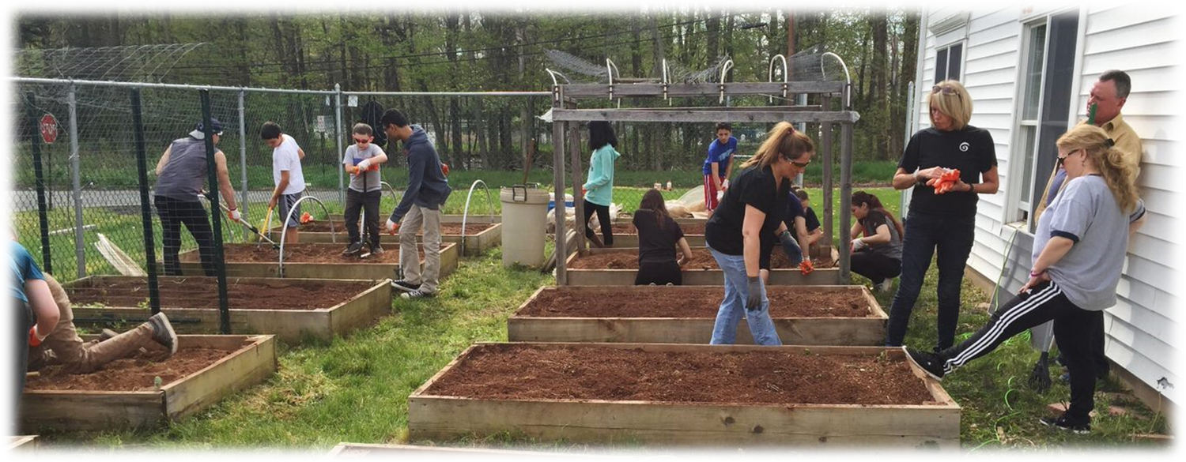

Speaking of new people in leadership, Raeann Dalton enthusiastically stepped in to plan, plant, and coordinate volunteers for our highly successful Jehovah Jira Garden, providing healthy vegetables and fruits to our neighbors! Raeann had previous experience with a similar garden while in college so she was the perfect choice for the role!
One more thing- the combination of our 2021 Thanksgiving and Christmas food drives provided full dinners for 24 local families who otherwise would have been without. Thanks to Annapurna and Subhas Budala for organizing, packing, and making sure the meals were delivered!
Bottom line: New Dover is a church that really takes God’s call to feed the hungry very seriously indeed!

STARS FOR CHARITY
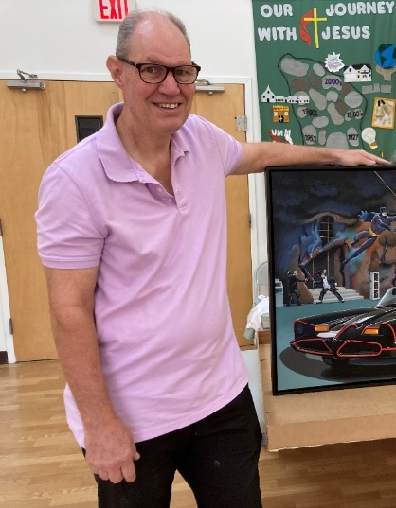

Started up and led by one of our newest church members, professional artist Bill Bunting, listed artists and church members were given plain wooden stars which they transformed into works of art. They were then auctioned on eBay as well as our Christmas luncheon. The proceeds were to be split between Bread Breakers and a South Jersey food nonprofit. Our goal was $2,000, but of course we did over $4,500! This looks like it will be an annual event to help us further help our food-insecure neighbors!

PEDALS FOR PROGRESS
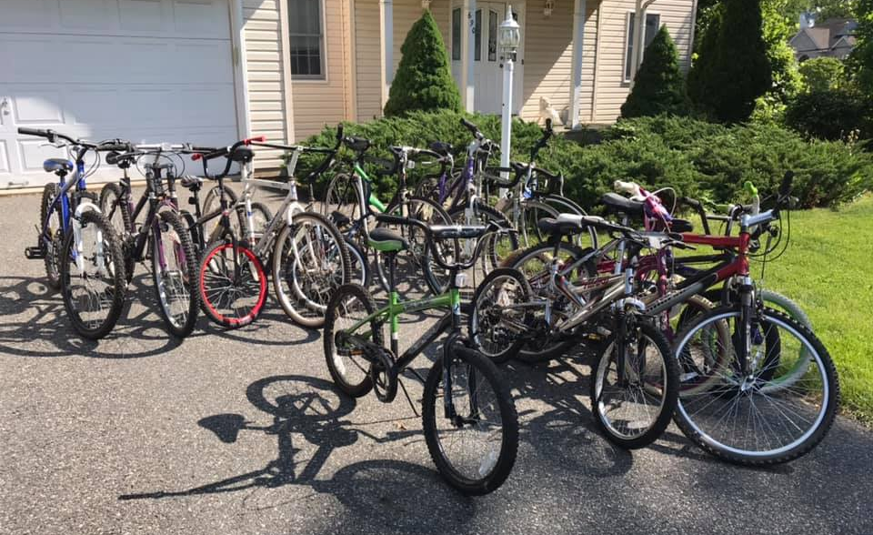
Although the numbers were down, mainly due to Brian Richard’s absence, we had another successful year for Pedals for Progress as we collected over twenty bikes, as well as five sewing machines. Once brought to the church on Saturday, June 4, the bikes were repaired to full working order then picked up by Pedals, to be delivered to our neighbors in developing nations, enabling them earn a living for their families!

VELLORE CHRISTIAN MEDICAL COLLEGE IN INDIA
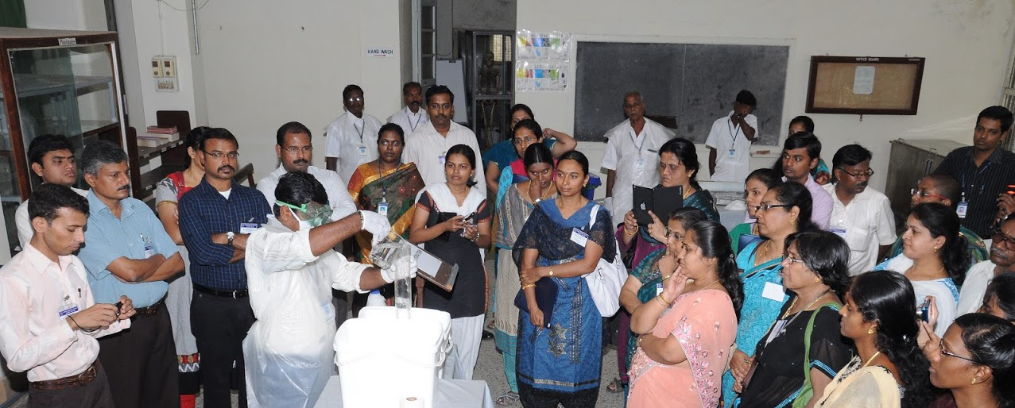

New Dover’s continues to cultivate its strong partnership with CMC. New Dover was honored this past spring at the 2022 CMC Foundation Gala in New York City for raising $38,000 to equip an entire Intensive Care Unit at the Medical College in 2021. I was asked to deliver the opening prayer at the Foundation’s annual meeting. This year New Dover also contributed $2,000 to go toward the construction of a badly needed maternity hospital in the rural, poverty-stricken Jawadhi Hills.

UKRAINE RELIEF

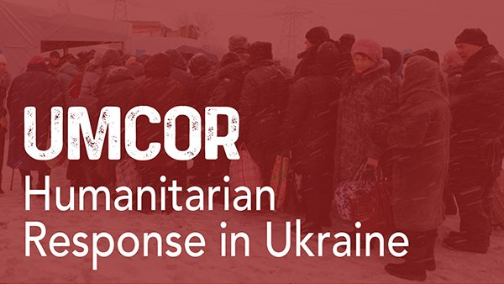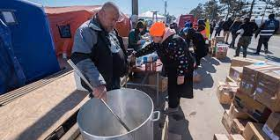
When the call went out for help for Ukrainian citizens and refugees caught in the throes of war, New Dover responded in a huge way, contributing over $8,000 to UMCOR! During worship and at Wednesday morning Prayer Fellowship, we continue to pray weekly for peace in Ukraine.

SOCIAL JUSTICE TASK FORCE
The SJTF had a fairly quiet year as the church focused on emerging from the pandemic. But plans are in the works to restart our important work in the fall with gun violence, immigration reform, religious nationalism, and women’s health care rights on the agenda.

NURTURE

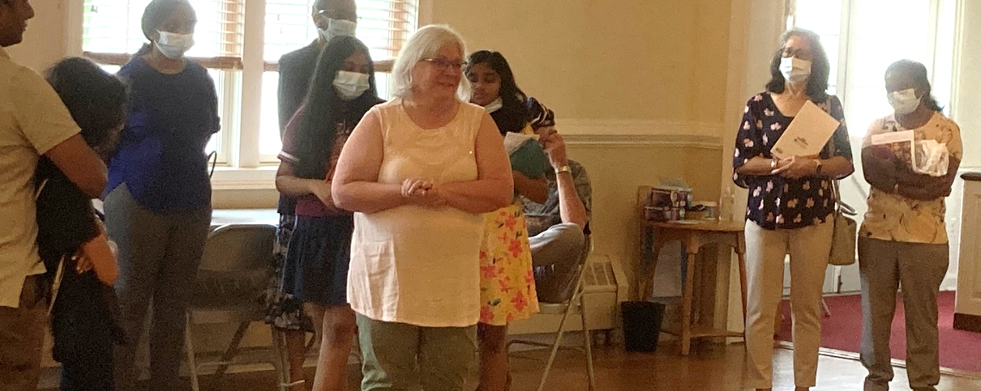
The Nurture Committee oversees a number of subcommittees, programs, and events such as Worship, Christian Education, family ministry, Shrove Tuesday, the Church Picnic, and the Strawberry Festival. It is also responsible for the care and contact of our church community.

WORSHIP

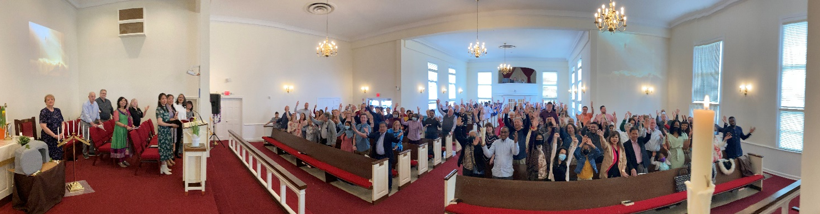

As I do each year, I want to begin with a description of what goes on behind the scenes at New Dover to make our worship service both moving and meaningful.
- The Worship Committee met on nine occasions during the past year.
- In the wake of the pandemic, the decision was made last fall to temporarily end the 8:30 worship service and revisit whether we should bring it back at the end of December. Due to the overwhelming success of the new 9:00 AM Adult Sunday School it was decided to end 8:30 Sunday worship until further notice.
- All Sunday morning and Saturday evening services continue to be livestreamed over Boxcast, Facebook, and YouTube. Our “Balcony Crew” volunteers do a remarkable job broadcasting New Dover’s worship to a worldwide congregation!
- Once the number of Covid cases abated we were able to return to regular worship in the sanctuary starting in June of 2021. Sanctuary worship continued unabated until January with the rise in Covid numbers due to the Omicron variant. Once the number of cases went back down we were able to safely return to the sanctuary on Ash Wednesday, and have continued live worship to the present.
- Our Musical Director, Dr. Grace Kim, did a wonderful job getting our adult choir back together in fine voice following the long layoff. She also arranged and rehearsed vocal pieces with numerous church members so that even when the choir was not singing we had sacred and inspirational music during worship. Grace and the Choir’s cantata program in Advent was especially beautiful!

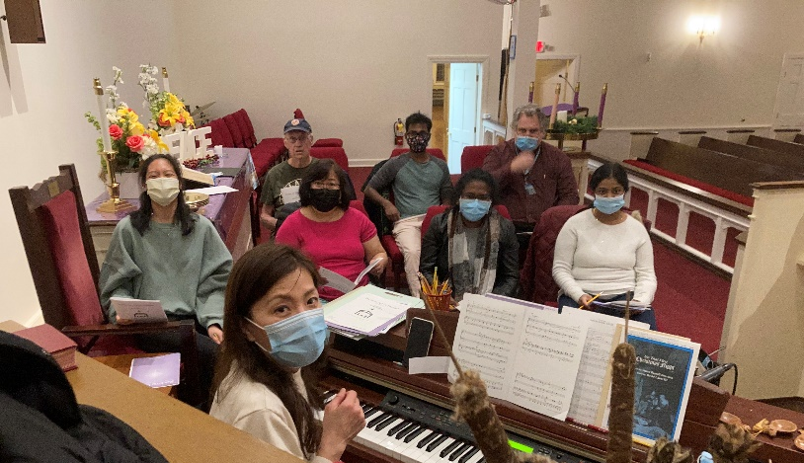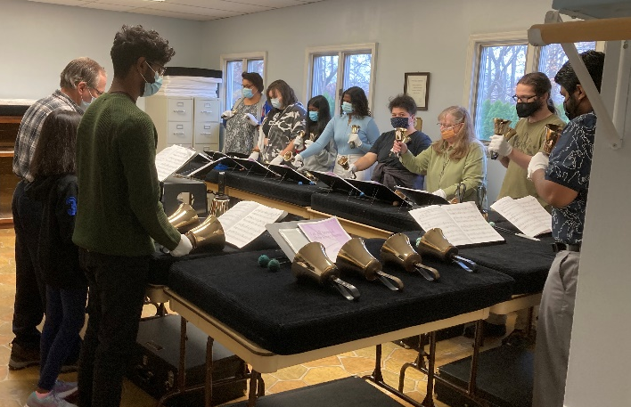

- Our magnificent Bell Choir, conducted by the incomparable Alice Bennet was back rehearsing weekly, and were pretty much adhering to their pre-Covid worship schedule. Alice continues to spread the bell choir mission to other churches in the Conference.
- Thanks to Madhu Christian and the Worship team, greeters, ushers, liturgists and counters were scheduled each and every week. Our nursery has reopened, and our popular post-worship coffee hour, overseen for the umpteenth year by Connie Thomas, was back for most of the year (Covid permitting!).
- Throughout the emergence from the pandemic and the transition back to “normalcy,” our admin (“Commander in Chief!”) Trish continued to format, print and publish our bulletins and newsletters in her normal professional manner
- Once again this year our Saturday Night Praise Service featured a number of song leaders with Kyle Sanders doing the bulk of the nights, followed by Emma Patrimonio, Jamie Conrad, Brian Christian, and the Manglapus family, Pastor Rosie preached and led worship every second and fifth Saturday of the month. Because of their gifts and dedication, our live attendance numbers are back to pre-Covid levels. We also pick up over a hundred other views online weekly.

Here are just a few highlights from New Dover’s year at worship…

- On World Communion Sunday 2021 we celebrated our congregation’s amazing diversity! Long-time New Dover Church member Fiona Meade preached a very personal and powerful sermon that morning.
- On Laity Sunday, October 17^{th,} seven church members, representing all ages, cultures, and talents, took part in our annual celebration of our incredible laity.
- On All Saints Sunday: November 1st, we held our annual service of remembrance of the lives of the Saints of New Dover who passed on to glory over the past year. Family members carried forward a photograph of their loved one which was then placed on the altar. Later we celebrated their eternal presence with us during Communion. As is our custom, we also paid special tribute to a Saint who served New Dover in past. This year we remembered the enduring lay ministry of Larry Hagar.
- Our November 21st Thanksgiving Service was a celebration of our ministry throughout the year. Using PowerPoint to illustrate, Bob Becker of our Finance Committee, addressed how the offerings of the congregation made a huge difference in the world, both locally and globally! The service spurred a remarkable increase in giving at the end of the year that helped us overcome what had been a sizable budget deficit!
- The 2020 Advent Season was all virtual, so it was great to be able to celebrate the season live in 2021! The congregation was invited to decorate the sanctuary on Saturday, December 4th and with plenty of coffee, snacks and Christmas carols playing, they did a fantastic job. Throughout Advent it was great to revisit our traditional worship offerings such as the lighting of the Advent wreath, the Bell Choir ,who rang on the 3rd Sunday, and our Cantata Choir, who sang on the 4th Sunday!

- Our Christmas Eve Candlelight Services were also back live this year with two services of Lessons and Carols, and it was great to see such an excellent turnout!
- New Year’s Eve’s 11:00 PM Watchnight Service, a partnership with the Telugu Church featured a number of readers and liturgists from both congregations. The service has become quite a tradition for many in our community.
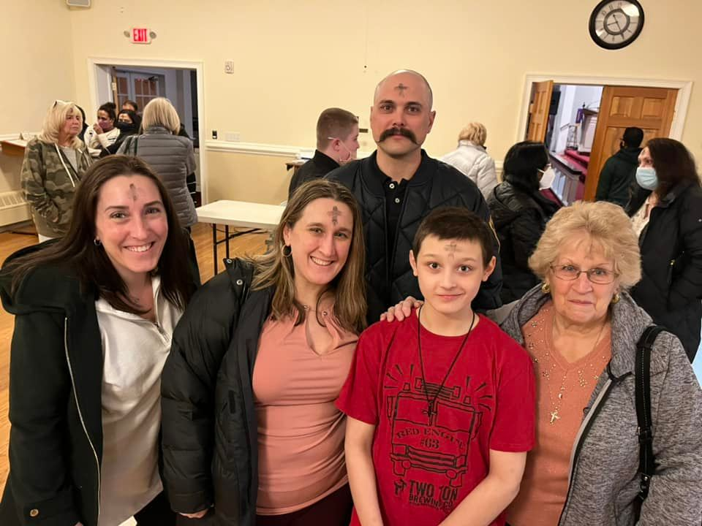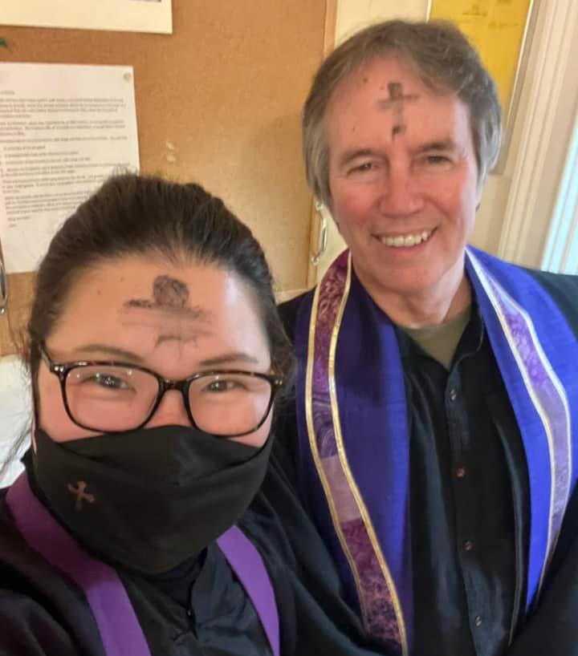

- Ash Wednesday on March 2nd marked our triumphant return to live worship after two months away due to Omicron. It was so cool to witness Pastor Rosie impose ashes for the first time!
- Palm Sunday worship featured our Bell Choir ringing out and our Chancel Choir singing out! That morning’s Coffee Hour featured a fond, loving farewell to the Samuel family, who were moving back to India. The Samuels have been such a vital part of our ministry over the years!
- Maundy Thursday was also back live this year. For the first time in three years we were able to gather around the table in Fellowship Hall (the Upper Room) with Karen Rowland giving a marvelous explanation of the Passover meal that Jesus ate with his disciples and friends. Following communion we made our way to the sanctuary, sang a hymn, and solemnly stripped the altar for Good Friday.
- Good Friday evening worship was a powerful service of Tenebrae with readings and music reflecting the sacred, somber mood as the candles were extinguished and the shadows enveloped us.
- Before our 6:30 Easter Sunrise Service began we found ourselves setting up an additional dozen chairs on the front lawn of the sanctuary, because when the dawn broke we beheld on a record breaking crowd of 28! Kyle Sanders led us in spirited praise and Lisa Gilmore took the liturgy. The 10:15 traditional service marked the highest attendance we had seen since before the pandemic began two years before. Grace and the Choir lifted us up to renewed heights, and the congregational singing raised the roof right off the foundations! There was joy and energy, laughter and tears throughout the service and everyone left church that morning feeling that, not only was the worst behind us, but the future was brighter than we could have imagined few months ago! And as if to put an exclamation point on all that, fifteen new adults requested to join our church that day!

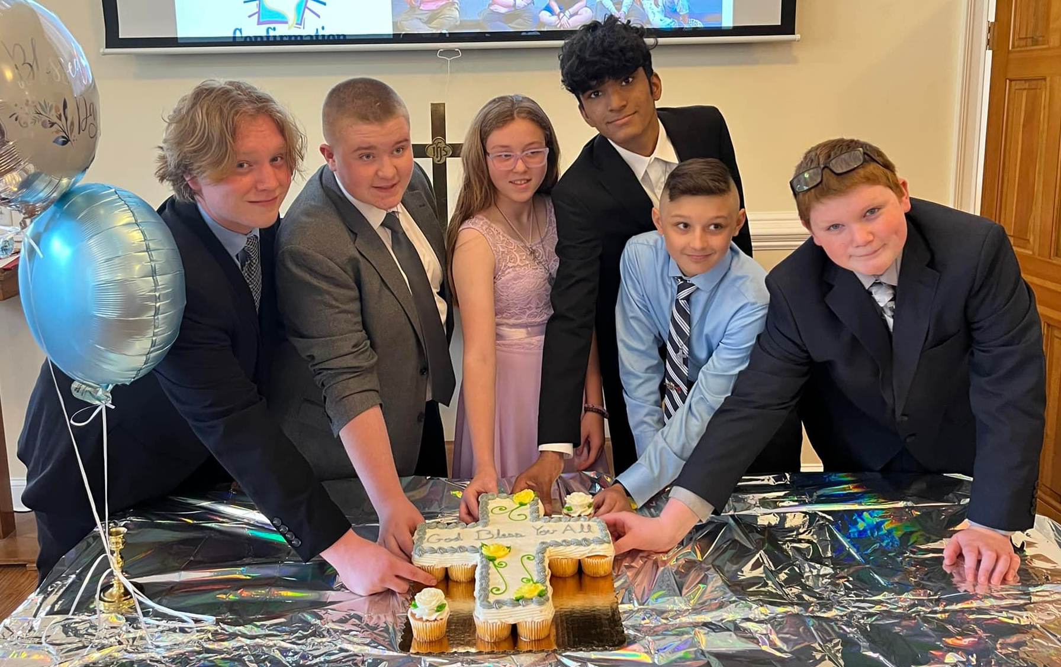
- Confirmation Sunday, May 22nd was a church-wide celebration of our great Class of 2022 confirmands! The Bell Choir rang and the confirmands led the liturgy. After a couple of lean years, it was great to see such a dedicated, energetic band of young disciples. New Dover’s future is bright!

CHRISTIAN EDUCATION

SUNDAY SCHOOL
Led by Pastor Rosie and our new superintendent, Catherine Poornaselvan, our Sunday School made a remarkable transition from virtual to hybrid. The youth attendance was back to pre-pandemic numbers. A big surprise was the success of our new Adult Sunday School that averaged over a dozen attendees throughout the year! Many parents were able to take part while their kids attended their classes.

VACATION BIBLE SCHOOL
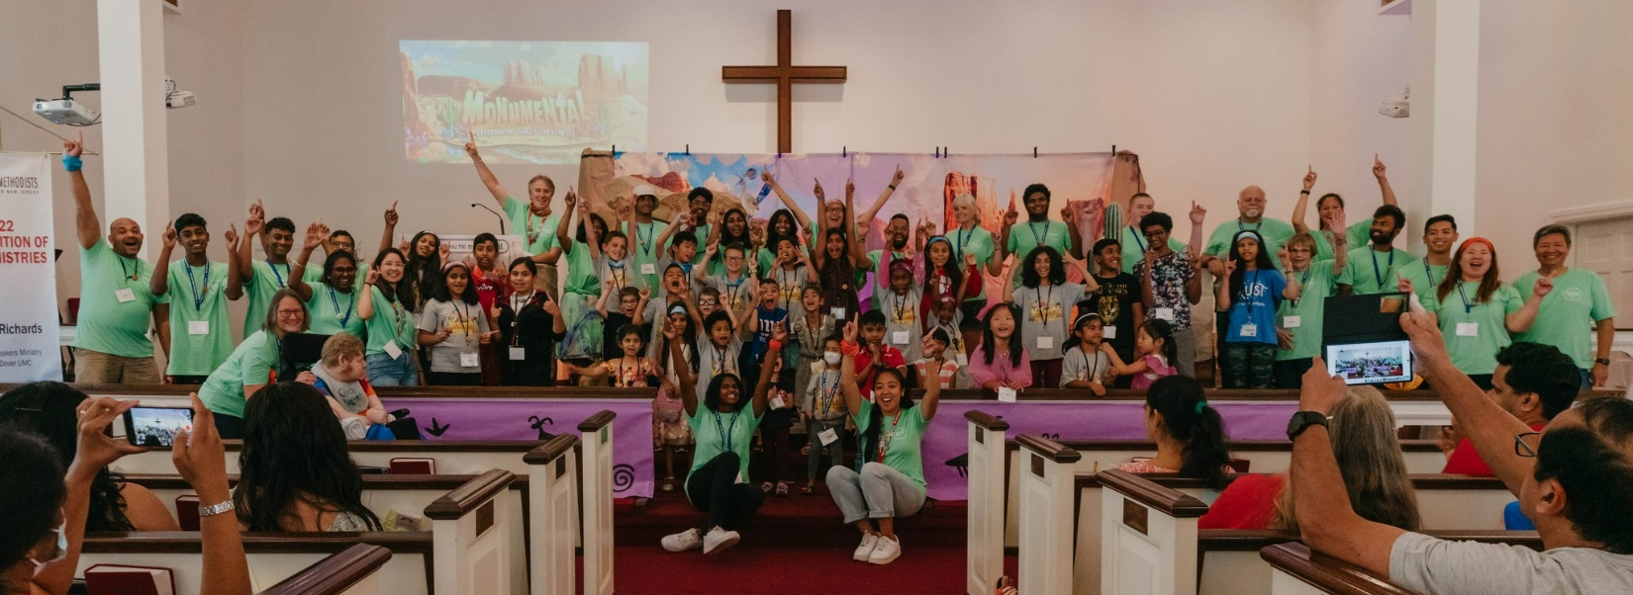
NDUMC VBS was held the week of July 25th. This year’s theme was “Monumental,” with a southwestern desert theme, and it was great to have the kids and volunteers back live for the first time since 2019! Rhea Manglapus and new co-director Naomi Hunt, with the help of the Manglapus family, Bill Bunting, the Nurture Committee, as well as dedicated VBS veterans and church members, planned, organized, taught, and presented yet another inspirational week of VBS at New Dover! It culminated with a live celebration on Friday and our annual VBS celebration at worship on Sunday the 31st.

Hot Topics
Starting last September, Hot Topics began a theme entitled “Vision Quest,” as way to prepare the church for the October 30th Vision Retreat. In November we started a sequel to the very popular Cults class from four years ago called simply “Cults II.” As before it was a fascinating way to examine alternative religious movements and talk about the differences between healthy and unhealthy religions. The Monday morning class met live and the Thursday night class met on Zoom. Both classes were well-attended, and enthusiasm for the class has extended it into the summer months!

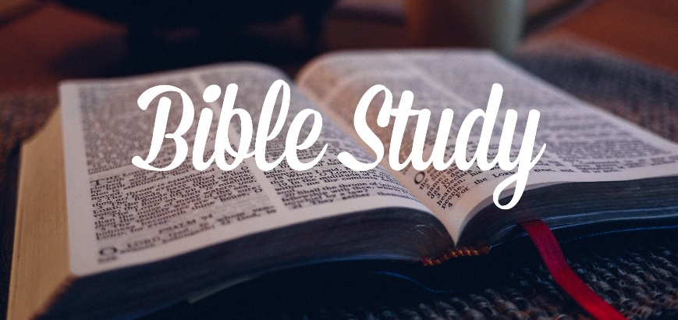
Anita Davis was able to have her weekly Friday night Bible Study meet live for the first time in two years. Their deep examination of scripture has proven to be a transformational force in the lives the attendees. Just ask them, and they will enthusiastically tell you!

ADMINISTRATION
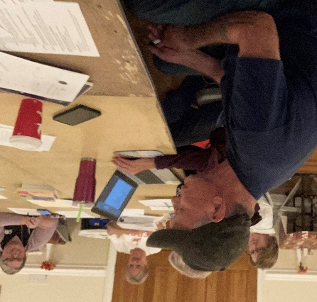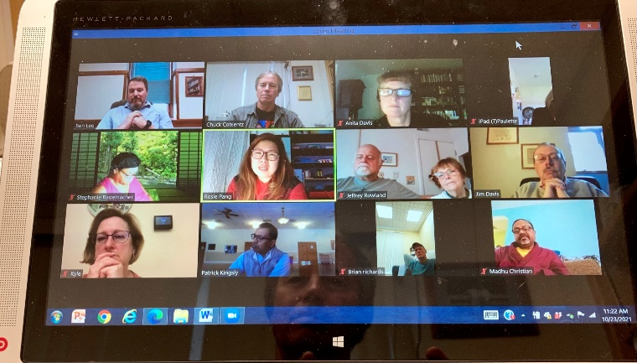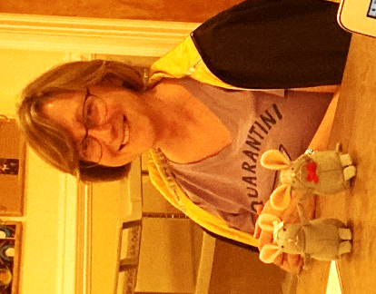

Please take the time to read the reports that our council members have submitted. Again this year I’m grateful to each serving member of the Church Council and Trustees for their dedication to the ministry of New Dover. Given the transition from the pandemic and the unexpected challenge of the Omicron variant, our church leadership once again demonstrated consistent wisdom, courage, and concern for the well-being of our parishioners.
Council Chair, Patrick Kingsly, continued to lead us forward, as always, starting each meeting with a devotion and getting the most out of each monthly gathering. Patrick has always been a hands-on leader in our congregation, and this year has been no exception!
Trustee President, Jeff Rowland, maintains an eagle eye on the buildings, grounds, and infrastructure, contacting professionals when needed, recommending upgrades, and coordinating with the other trustees. Jeff continues to supervise our Tuesday Flea Market which has been back in full swing since March.
Paulette Harland, in addition to her previously mentioned work in the Dominican Republic, continued to chair our Outreach Committee, strengthening current missions and exploring new opportunities for ministry.
Our treasurer, Michelle O’Rourke, continues to do a fantastic job paying our bills and keeping our books straight. It’s always a bright day when she’s working alongside Trish in the office!
Despite a very, let’s say, “dramatic” up and down and ultimately up year in terms of our budget, Finance Chair, Joanne Lettieri, offered a monthly hopeful yet blunt assessment of where we were financially throughout the year. No one was happier to see the miraculous giving that brought our budget back in line by the close of 2021!
Our new Lay Leader, Stephanie Rademacher, came into the position with loads of energy, imagination, and enthusiasm. I have found that you’d like Stephanie to do something, just ask! If at all possible she finds a way to come through. Stephanie is so dedicated to the ministry of New Dover!
Once again in a challenging year, our Worship Committee chair, Karen Rowland led her committee with wisdom and enthusiasm! I believe Karen sees leadership as a two-way street and she takes every suggestion and opinion by the pastors and committee members under serious consideration and discussion. That is a big reason why our worship life at New Dover remains one of consistently effective inspiration!
In yet another interesting year to be a United Methodist(!), our Lay Delegate, Brian Richards, once again sat in with me for two days to take part and vote in the GNJ Zoom Conference. Brian then reported the results back to the Council and Church. In addition to serving on Trustees, Brian continued to effectively and efficiently run our Mission Hub and Bread Breakers food ministry with his typical. We have already been missing his energy and enthusiasm around the church since he and Pat moved to New York!

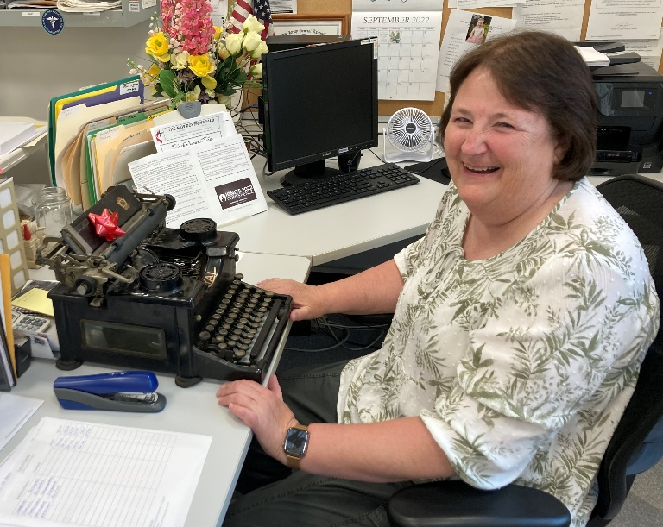

Finally, a heartfelt thanks to our administrative assistant (aka “Commander in Chief!”) Trish Boyce- whose welcoming demeanor, steady work ethic, and wry sense of humor keeps our office friendly, efficient, and fun throughout the year! Beyond her “job,” Trish has taken on an active role with Bread Breakers!

VISION RETREAT

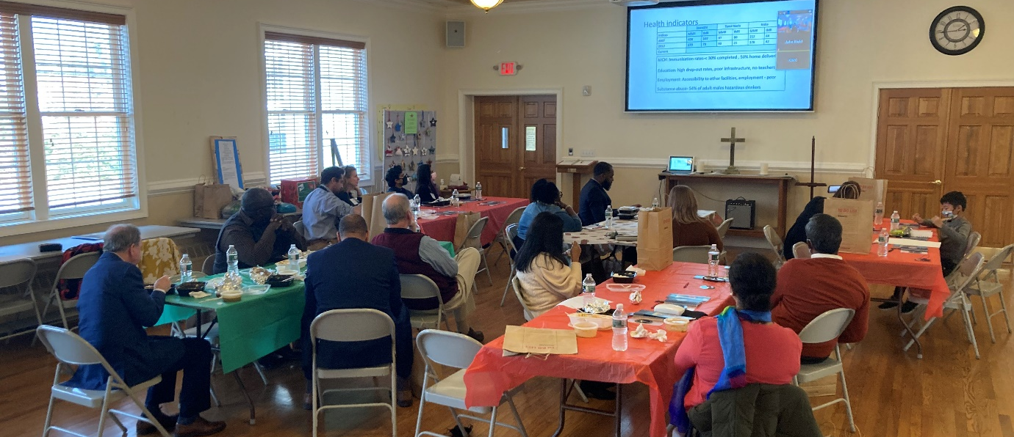
On October 30th, New Dover United Methodist Church held a Vision Retreat in which, among other things, we decided to use a major portion of the money raised from the sale of the property left to us by Evelyn Millard to enlarge our mission center, enabling us to expand and enhance our outreach ministry both locally and globally. This idea was then passed on to our Church Council who was asked to formulate a way forward. The Council decided that before we planned the center's construction, we first needed to agree on how it should function. Where do we feel God is leading us in this incredible opportunity? What areas of mission should it address? For that reason, they asked me to assemble a "task force" so that the invitees would have an opportunity to share your thoughts on what you believe this center should accomplish.
The task force came up with a series of objectives, that were passed on to Council for review and refinement. Ultimately the goal is to have the congregation vote on a comprehensive plan that will be presented sometime in the near future. Once the plan is approved, Council will then empower the Trustees to begin the process leading to construction.
In addition to the mission center, the Vision Retreat identified a number of other exiting ways we can expand enhance our ministry. Among them:
- Purchase a 16 passenger bus for various activities and missions.
- Installing solar panels on the new roof in order to continue our push toward greener energy usage.
- Strengthen our connections with both the Township and the Conference.
- Develop partnerships with other organizations such as senior citizen and veteran facilities.

Youth and Young Adult (YAYA) Ministry
(Please see Pastor Rosie’s report)
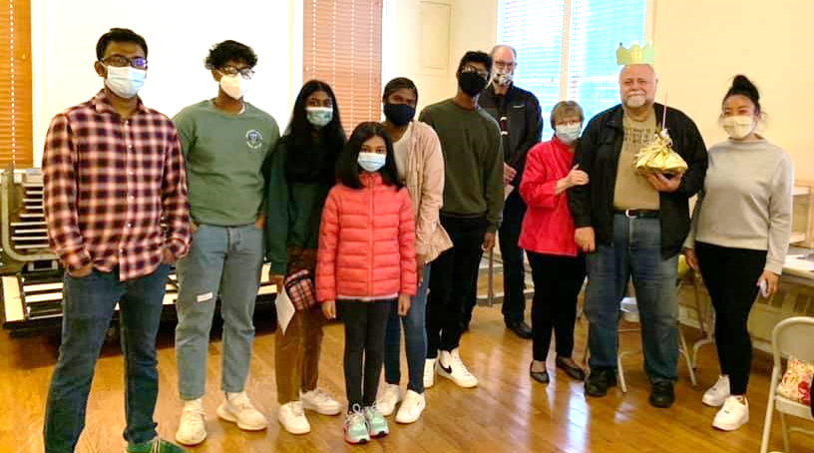

I’ll just comment that our youth and young adults have become a real inspiration and backbone of our church. The future is now at New Dover!

Metuchen Edison Area Interfaith Clergy Association

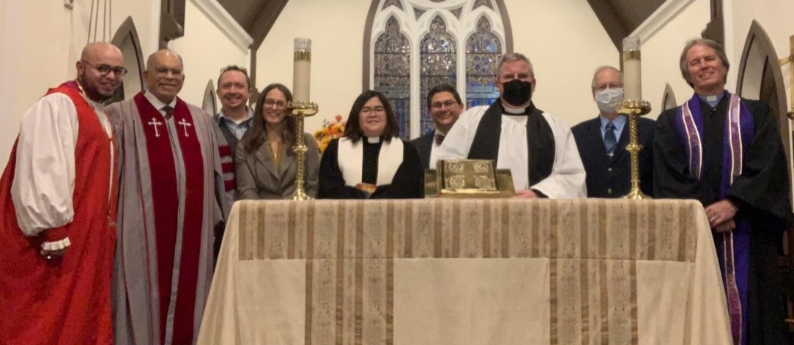
Just like last year, I took a vacation week in June, missed a meeting and because of that was once again unanimously elected by my peers to serve as President of MEAICA for the coming year. After a year of Zoom meetings and a mixed live and virtual Yom HaShoah service in April we can hopefully get back to having events such as our annual hunger walk. I also appreciate that a few of the houses of worship supported New Dover’s ICU India fundraiser.

Some Final Thoughts

I mentioned at the start- this has been some year of serious transition! We have had a number of vital church leaders move out of the area, and there are a couple more who are planning to move out in the year ahead. That’s the sad news. The good news is that we have had gifted church members step up to bring their own ideas and energy to the open positions!
So far we have not witnessed a slow-down in our committees and fellowships going forward. On the contrary, Outreach and Nurture have continued to grow in numbers and effectiveness, and I anticipate continued strengthening as we march forward into 2023. God has been so faithful to our congregation, and we remain a church blessed with vision, focus, enthusiasm, and a work ethic that builds God’s Kingdom each and every day!

Your Servant in Christ,
Chuck
Rev Chuck Coblentz

